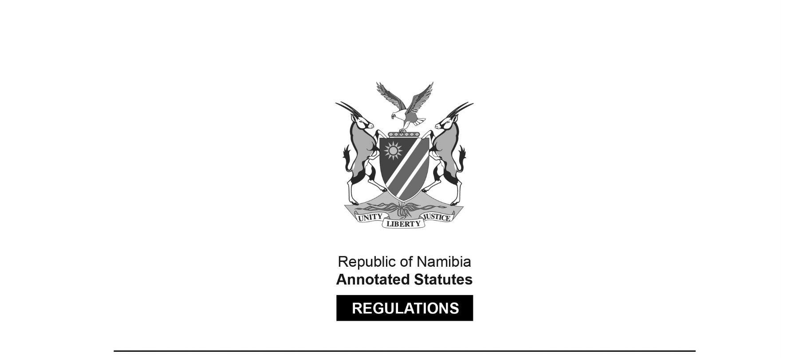

REGULATIONS MADE IN TERMS OF

Cattle Improvement Consolidation  
Ordinance 14 of 1941

section 13

Cattle Improvement Regulations

Government Notice 87 of 1941

([OG 904](http://www.lac.org.na/laws/1941/og904pdf))

came into force on date of publication: 2 June 1941

as amended by

Government Notice 47 of 1943 **(**[OG 1035](http://www.lac.org.na/laws/1941/og1035.pdf)**)**

came into force on date of publication: 2 June 1941

ARRANGEMENT OF REGULATIONS

[These regulations do not have headings.]

**1.** In these regulations -

“the Ordinance” means the Cattle Improvement Consolidation Ordinance, 1941 (Ordinance No. 14 of 1941), and any amendments thereof;

“board” means a board appointed by the Administrator in terms of section *three* of the Ordinance;

“cattle improvement area’ means any district or defined area duly declared to be a cattle improvement area by proclamation issued under section *one* of the Ordinance;

[The single quotation mark after “cattle improvement area” should be a double quotation mark.]

“registered bull” means a bull the pedigree of which has been registered with a Society approved by the Administrator;

All other expressions shall, unless inconsistent with the context, bear the meanings assigned to them in the Ordinance.

**2.** Members of a Board constituted under section *three* of the Ordinance other than public servants shall be entitled to the following allowances for the time necessarily spent in attendance at Board meetings and in travelling to and returning from the place of such meetings or otherwise in connection with their duties as such members -

(a) Subsistence allowance at the rate of £1 per day or portion thereof.

(b) Free transport by rail.

(c) Horse transport allowance at the rate of 2d. per mile.

(d) Motor transport allowance at the rate of 9d. per mile, plus an additional 1d. per mile in respect of each passenger carried, whose attendance is necessary in connection with the activities of the Board.

**3.** Any person who desires to introduce an unapproved bull into a cattle improvement area, in terms of section *six* (b)(i) of the Ordinance shall make application to the officer appointed for the area in the manner prescribed hereunder at least one week before the date on which he wishes to introduce such bull.

APPLICATION FOR PERMIT FOR INTRODUCTION OF UNAPPROVED BULL.

|  |  |  |  |
| --- | --- | --- | --- |
| I, the undersigned, do hereby apply for permission to introduce on to the farm | | | |
| district of the bull(s) specified | | | |
| below from the farm | | | |
| district of | | | |
| Breed. | Age. | Description, including brands and identification marks. | |
|  |  |  | |
| Address: | | | |
| Date: | | | |
|  | | |  |
|  | | | SIGNATURE. |

**4.** Every non-registered bull which has been duly inspected and approved by a Board shall in terms of subsection (1) of section *seven* of the Ordinance forthwith be marked in the left ear with a tattoomark (thus: )

and the owner of such bull shall also forthwith cause it to be branded on the left forearm with two arched A’s, with the one inverted and the arches facing (thus:).

**5.** Every non-registered bull which has been duly inspected and provisionally approved by a Board shall, in terms of sub-section (2) of section *seven* of the Ordinance forthwith be marked in the left ear with a tattoo mark (thus: ) and the owner of such bull shall also forthwith cause it to be branded on the left forearm with one arched A (thus:ʧ"°).

**6.** When a bull has been duly inspected, and approved or provisionally approved, and branded and marked as described in regulation 4 or 5 as the case may be, the officer shall allot to such bull a distinctive mark consisting of the dominant letter for the district as set forth in the second schedule to the Stock Brands Ordinance, 1931 (Ordinance No. 8 of 1931) and a number which shall be the serial number of that bull in the register to be kept in terms of sub-section (4) of section *seven* of the Ordinance.

Such distinctive mark shall forthwith be tattooed in the right ear of the animal to which it has been allotted.

[The Stock Brands Ordinance 8 of 1931 has been replaced by the Stock Brands Act 24 of 1995.]

**7.** The owner of any registered bull shall cause such animal to be branded on the left forearm with an inverted arched A (thus: ) and shall furnish the officer appointed for the cattle improvement area wherein such animal is kept with full particulars regarding its breed, age and description, and proof of registration, giving Studbook or Herd-book number and identification brand or mark.

The officer aforesaid shall record all these particulars in a register to be kept by him.

**8.** When an unapproved bull has been duly inspected and. disapproved by a Board the owner of such bull shall in terms of sub-section (3) of section *seven* of the Ordinance, forthwith cause it to be branded on the left forearm with an arched A branded horizontally with the arch pointing to the right (thus:), unless the owner is agreeable to the immediate castration of said bull under the supervision of the Board or immediately notifies his intention to appeal.

**9.** Where a bull which has been previously inspected and provisionally approved by a Board in terms of section *four* of the Ordinance, is subsequently disapproved, the owner of such animal shall then return to the officer concerned the certificate of inspection and provisional approval previously issued for purposes of cancellation and the cancellation thereof shall be denoted on the animal itself by means of an arched A branded horizontally with the arch pointing to the right (thus: ) immediately above the arched A branded on the animal’s left forearm at the time of the original inspection and provisional approval, unless the owner is agreeable to the immediate castration of the bull under the supervision of the Board or immediately notifies his intention to appeal.

**10.** When a bull has been inspected and approved or provisionally approved by a Board and marked in accordance with these regulations, the officer concerned shall issue to the owner of the bull a certificate in the following form -

|  |  |  |  |  |  |  |  |  |  |
| --- | --- | --- | --- | --- | --- | --- | --- | --- | --- |
|  | | | | | CERTIFICATE OF INSPECTION AND | | |  | |
|  | | | | |  | * PROVISIONAL APPROVAL | |  | |
|  | | | | |  | APPROVAL | |  | |
|  | | | | |  | issued under | |  | |
| CATTLE IMPROVEMENT CONSOLIDATION ORDINANCE, 1941  (ORDINANCE NO. 14 OF 1941). | | | | | | | | | |
| Name of Owner: | | | | | | | | | |
| Address: | | | | | | | | | |
| Name of Bull: | | | | | | | | | |
| Age: | | | | | | | | | |
| Breed: | | | | | | | | | |
| Serial No. allotted. | | | Tattoo mark. | | | | Brand. | | Other identification marks. |
|  | | |  | | | |  | |  |
| I, the undersigned, do hereby certify that the above-mentioned bull was inspected on | | | | | | | | | |
| by a Board consisting of | | | | | | | | | |
| and * provisionally approved for purposes of the breeding of cattle. | | | | | | | | | |
|  | approved | | |  | | | | | |
| Dated at this day | | | | | | | | | |
| of 194 | | | | | | | | | |
|  | |  | | | | | | | |
|  | | OFFICER CATTLE IMPROVEMENT AREA. | | | | | | | |
| * Delete what does not apply. | | | | | | | | | |

**11.** The Administrator may grant a loan to an owner of stock for the purpose of paying for, in full or in part, a bull to replace a bull disapproved of by a Board, provided that -

(a) Board has so recommended;

(b) the Administrator is satisfied that the applicant is not financially in a position to purchase a suitable bull without such assistance, and

(c) the bull to be purchased has been approved of by a Board or is a registered bull.

[regulation 11 inserted by GN 47/1943]

**12.** Application for a loan shall be made in the form specified in the annexure hereto. Any person who willfully makes a false statement in such application shall be guilty of an offence and liable on conviction to a fine not exceeding £25 or in default of payment to imprisonment for a period not exceeding 3 months.

[regulation 12 inserted by GN 47/1943]

**13.** The loan shall be repayable, without interest, in equal half-yearly instalments over a period of three years from the date of payment thereof.

[regulation 13 inserted by GN 47/1943]

**14.** The first instalment shall become due and payable at the expiration of six months from the date of payment of the loan and subsequent instalments shall become due and payable every six months thereafter.

[regulation 14 inserted by GN 47/1943]

**15.** In the event of an owner failing to pay the instalments on the due dates, interest at the rate of six per centum per annum shall become payable thereon from the due date to the date of payment.

[regulation 15 inserted by GN 47/1943]

**16.** All payments shall be made at the office of the Magistrate of the district in which the owner resides, or at such other places as the Administrator may direct.

[regulation 16 inserted by GN 47/1943]

**17.** Until the amount of the loan with any interest which may become due under the provisions of regulation 15, shall by fully paid, the bull(s) purchased shall remain the sole and absolute property of the Administrator and the ownership thereof shall not pass to or vest in the owner, but upon payment of the last instalment and any interest due, the said bull(s) shall become the sole and absolute property of the owner.

[regulation 17 inserted by GN 47/1943]

**18.** Until the said bull(s) shall have become the property of the owner he shall not be entitled to sell, let, pledge, or in any other way alienate, encumber or part with the possession of the said bull(s).

[regulation 18 inserted by GN 47/1943]

**19.** Any loss whether due to death, straying, theft or any other cause which may occur to the said bull(s) shall fall upon the owner, nothwithstanding that the ownership of the bull(s) shall, at the time of such loss, be vested in the Administrator.

[Regulation 19 is inserted by GN 47/1943. The word “notwithstanding”   
is misspelt in the *Official Gazette*, as reproduced above.]

**20.** Upon request by the Board the owner shall be obliged to produce the said bull(s) at all reasonable times for the purpose of inspection thereof by any person acting on behalf of a Board.

[regulation 20 inserted by GN 47/1943]

**21.** If an owner shall fail to pay any instalments on the due date, or any interest due or if he shall commit any breach of regulations 18 and 20 the Administrator shall be entitled forthwith to resume possession of and to remove the said bull(s) without recourse to law, or the Administrator may apply to any court of competent jurisdiction for an order restoring possession of the said bull(s) to the Administrator, and the owner shall, on such resumption of possession and removal or on such restoration, have no claim whatsoever to a refund of any sum or sums already paid by him by way of instalments and interest, but shall nevertheless remain liable for all arrear instalments plus any interest due thereon as provided in paragraph 15 hereof, and for all damages which the Administrator may sustain by reason of the breach of these regulations.

[regulation 21 inserted by GN 47/1943]

SCHEDULE

[The Schedule is inserted by GN 47/1943.

Note that the word “Donkeys” in the section on large stock   
is misspelt in the *Official Gazette*, as reproduced below.]

|  |  |  |  |  |
| --- | --- | --- | --- | --- |
| Application for a loan under the provisions of the Cattle Improvement Regulations - | | | | |
| 1. Full name of application | | | | |
| Address | | | Date | |
| District | | | | |
| 2. Whether applicant owns immovable property. | | | | |
| 3. Particulars thereof - | | | | |
| Name of farm | | | | |
| Extent | | | | hectares |
| Whether registered in applicant’s name or not. | | | | |
| Whether bonded or not. If bonded, state number and amount of bonds. | | | | |
| 4. Movable property, e.g. wagons, carts, motorcars, lorries, ploughs, harrows, etc. | | | | |
|  | | | | |
|  | | | | |
|  | | | | |
|  | | | | |
| STOCK | | | | |
| *Large stock:* | | | | |
| Cattle | | | | |
| Horses | | | | |
| Mules | | | | |
| Donkies | | | | |
| *Small stock:* | | | | |
| Sheep | | | | |
| Goats | | | | |
| Pigs | | | | |
|  | |  | | |
|  | Signature of Applicant | | | |
| WITNESS: | | | | |
|  | | | | |



|  |
| --- |
| N.B. - Any person who wilfully makes a false statement in such application shall be guilty of an offence and liable on conviction to a fine not exceeding £25 or in default of payment to imprisonment for a period not exceeding 3 months. |